Dear Parents,

My first year as Chair of FoSM has been a wonderful and rewarding experience, and I am pleased to say that, along with Georgina (Vice-chair) and Bernice (Treasurer) - we are all here for another year! In this newsletter are some of the FoSM highlights of the year, what we have done, what we have contributed to the school and how much money we have all raised. It is also a thank you to everyone who supports FoSM – you are a truly amazing school community!

Thanks from your FoSM Chair
I can’t go any further without a round-up of thanks for the year, there are so many people who help me! Polly - a huge thanks to you for supporting the new FoSM team at the start of the year; Georgina - somehow you put up with my endless list of requests, you’re a wonderful Vice-chair; Bernice – a fantastic treasurer, you put in many hours to ensure the financial administration of FoSM runs like clockwork; Neelam and Dawn – thanks so much for your help with many of the adhoc events and activities that we run; Year Group Reps - thanks for your hard work before and during fairs and events, the work you do for your class and your communications to the parents – you are the heart of FoSM. There are so many other parents and staff out there who contribute huge amounts to FoSM, I hope I have shown my appreciation for what you do and that you know how much you are all valued. And lastly, to everyone who comes along to our fairs and events and supports FoSM – a huge thanks to you all.

FoSM net total raised for the year is approx. £33K!!
Since the beginning of the academic year, FoSM has raised a phenomenal £33K for our school (final numbers available in October). This is an AMAZING achievement for everyone and something to be enormously proud of. This includes the final total for year group Cake Sales which is £4,340.87 - an incredible sum of money to raise from cakes, well done to everyone!

FoSM purchases for academic year 2017-2018
From the hard work everyone has put in raising money over the years, we have been very fortunate to have four major projects funded by FoSM this year: the reception playground improvement, the Collins Big Cat reading scheme books for reception to yr6, Reflection Rooms for all three sites and the middle site air conditioning. Each one of these projects are large spends for FoSM and are major upgrades and improvements for our school. Our annual FoSM contributions include: playground equipment (e.g. infant site mud kitchen), IT equipment (3x Casio projectors), Education City – an online educational resource, water bottles for reception, gluesticks, First News - weekly newspaper for 7yrs to 14yrs, Shortfall Fund for school trips and revision books, yr6 leavers book voucher and cinema trip, chocolate bunnies for annual Easter Egg Hunt, Christmas tree for all three sites and supplies for the infant site Christmas party. There is a huge range and wealth of projects, resources, equipment and funds that FoSM provides and I just want to take this opportunity to please ask you to keep supporting FoSM, helping in any way that you can so that we can keep providing these amazing resources for the educational environment of our children - thank you!

Cake Sale purchases for academic year 2017-2018
Cake sales have raised a total of £4,340.87, of which £3,564.83 has been spent on:

- Stationery supplies £1,561.09
- Project supplies £975.11
- School trips £513.00
- Books £289.40
- Cameras £183.93
- IT Subscriptions £42.30

An amazing achievement for everyone who has baked and bought a cake across all year groups, look at what you have provided for our school – amazing!

A round-up of FoSM activities and events for academic year 2017-2018
And so, just a little reminder of what FoSM have done this year academic year, you may have helped, organised, bought a ticket or come along to one of these events or activities, but whatever you did, thank you, you make our school community a truly special one:

- Cake Sales x 3 per year group
- New parents drinks evening
- October Quiz and Curry
- November Book Fair across all three sites
- Cake stall at the Orleans Park School fireworks night
- Christmas Silent Auction
- Christmas Cards
- Nativity DVD
- Christmas Fair
- Easter Bags of Love to Uganda Appeal
- Ceilidh and Curry in March
- Easter Egg Hunt
- Summer Party (for St Mary’s Fund – Sarah H)
- Summer Fair
- Poster competition for Summer and Christmas fairs
- Summer and Christmas fair raffles
- Tea towel fundraiser
- Coffee mornings for school events
- Helping at St Margarets Fair

Reps for next academic year
If you would like to continue to be a rep or would like to help the FoSM team in any way, please let me know by emailing chair.fosm@googlemail.com. All help small or large, very welcome.

Joy for Languages after-school club
New Spanish club from September, Mondays 3:40 to 4:20pm at Twickenham Library. Classes will start Monday 24th September. To register please go to http://www.joyforlanguages.co.uk and choose “Monday Spanish Open Centre”. Registration is now open! For further information please contact gacostarubio@googlemail.com. A donation to FoSM will be made for St Mary’s parents who sign up.

Follow FoSM on Facebook - https://www.facebook.com/FoSM-341208149309335/

Easyfundraising – shop and raise FoSM funds
https://www.easyfundraising.org.uk/causes/friendsofstmarystwick/?t=PTA-UK-li&u=CPPREK

So, that’s it for this academic year, FoSM is clocking off until the Autumn term. I wish you and your families a wonderful summer break and look forward to seeing you in September.

Best Wishes
Emily Price
Chair of FoSM

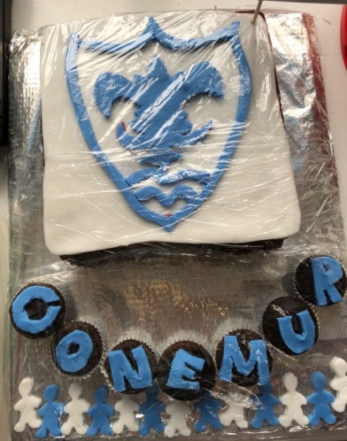
The Summer Fair Bake Off

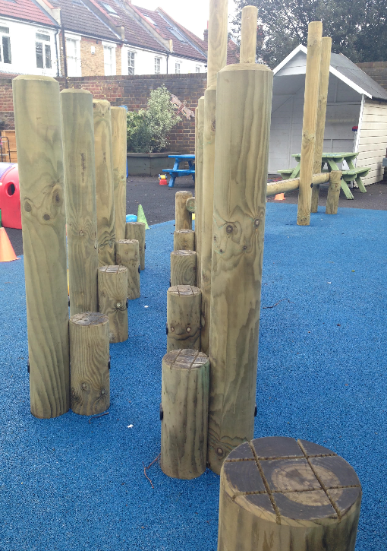
Reception Playground Upgrade
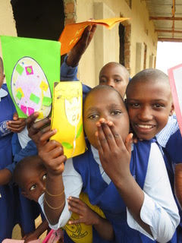
Easter Bags of Love to Uganda

